The title of your paper goes here
First A. Corresponding Author^{*1}, Second B. Author², Third C. Author, Fourth D. Author³, and Fifth E. Author⁴
Abstract—This electronic document is a “live” template and already defines the components of your paper [title, text, heads, etc.] in its style sheet. *CRITICAL: Do Not Use Symbols, Special Characters, Footnotes, or Math in Paper Title or Abstract. (Abstract)
Keywords—component, formatting, style, styling, insert (key words)

Introduction (Heading 1)
Please use this Microsoft Word™ based template for preparation of your abstract. The manuscript must be submitted as .pdf file. Use the following format for the file name: “AbstractID_ISSTT22_LastName (e.g. REG-0023_ISSTT2022_Smith). Total length of the manuscript shall not exceed 6 pages for regular submissions (with a minimum of 2 pages). If you are submitting a manuscript for consideration for the ISSTT 2022 Special Issue on the IEEE Terahertz Science and Technology Transactions, please upload a 2-page max manuscript for the ISSTT 2022 proceedings before submitting your papers to IEEE TST. Papers will not be considered for review for the Special Issue if the 2-pages manuscript has not been previously submitted.
Every year we work with the T-TST to publish a special issue containing papers that were presented at the ISSTT. This year the deadline for submitting papers to T-TST is April 30, 2023. Please note that the paper will be peer-reviewed just like a regular submission to the T-TST. Please use IEEE guide to prepare your manuscripts.

https://journals.ieeeauthorcenter.ieee.org/submit-your-article-for-peer-review/the-ieee-article-submission-process/

This is available on the IEEE Author Center. Once ready for submission follow the normal procedure. However, when it comes to Step 1 please select “Special Issue Paper”. Follow the remaining steps as you will for a regular submission. If you like you can further indicate that this is for the ISSTT special issue in the comments sections (Step 6).
All type is Times New Roman. The title of the abstract is in bold, type size 18 with a maximum of two lines and centered. A line space of 11 pt size follows the abstract title. The authors’ initials and last name are in type size 11. Authors’ institutions and email address of the corresponding author (does not have to be the first author) are italicized, type size 10 and centered. This is followed by a line space in type size 10. Text of the abstract is in type size 10 and justified. Figures, diagrams, tables or photographs can be included in the abstract as long as the 1-page maximum length is respectred. Please use a “Page Setup” of Margins (1” for all of top, bottom, left and right), Paper (“US Letter,” which is 8.5” wide by 11” long) and Layout (both header and footer are 0.5”).
Place figures and tables at the top and bottom of columns. Avoid placing them in the middle of columns. Large figures and tables may span across both columns. Figure captions should be below the figures; table heads should appear above the tables. Insert figures and tables after they are cited in the text. Use the abbreviation “Fig. 1”, even at the beginning of a sentence. Figure Labels: Use 8 point Times New Roman for Figure labels.

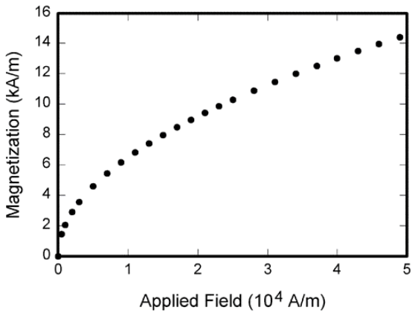
- Example of a figure caption. (figure caption)
- Table Type Styles
Table Head | Table Column Head
 | Table column subhead | Subhead | Subhead
copy | More table copy

Results

The proceedings will be made available for download on the Symposium website and additionally be archived at the NRAO website. There will not be a paper print of the proceedings. The publications passing the standard peer-review process will be published in an ISSTT special issue section of the IEEE Transactions on Terahertz Science and Technology.

References
- First Author, et al., “Manuscript Title”, Name of Journal, Mon. YYYY.
First Author, et al., “Manuscript Title”, Name of Journal, Mon. YYYY

¹First Affiliation, City, Postal Code, Country; ²Second Affiliation, City, Postal Code, Country; ³Third Affiliation, City, Postal Code, Country; ⁴Fourth Affiliation, City, Postal Code, Country

