The title of your paper goes here
First A. Corresponding Author^{*1}, Second B. Author², Third C. Author, Fourth D. Author³, and Fifth E. Author⁴
Abstract—This electronic document is a “live” template and already defines the components of your paper [title, text, heads, etc.] in its style sheet. *CRITICAL: Do Not Use Symbols, Special Characters, Footnotes, or Math in Paper Title or Abstract. (Abstract)
Keywords—component, formatting, style, styling, insert (key words)

Introduction (Heading 1)
Please use this Microsoft Word™ based template for preparation of your abstract. The abstract must be submitted as .pdf file. Use the following format for the file name: “LastName_isstt2022abstract_#” where # is either “1”, or ”2”, depending on how many abstracts you are going to submit. Total length of the abstract text (not including title, names and listing of institutions) should not exceed 1 page for regular submissions. All type is Times New Roman. The title of the abstract is in bold, type size 18 with a maximum of two lines and centered. A line space of 11 pt size follows the abstract title. The authors’ initials and last name are in type size 11. Authors’ institutions and email address of the corresponding author (does not have to be the first author) are italicized, type size 10 and centered. This is followed by a line space in type size 10. Text of the abstract is in type size 10 and justified. Figures, diagrams, tables or photographs can be included in the abstract as long as the 1-page maximum length is respectred. Please use a “Page Setup” of Margins (1” for all of top, bottom, left and right), Paper (“US Letter,” which is 8.5” wide by 11” long) and Layout (both header and footer are 0.5”).
The abstract can have multiple paragraphs, but please do not use a line space between paragraphs. The maximum length for the abstract is one page. Your abstract will be technically reviewed and we will let you know if it has been accepted or not in a timely fashion. Please indicate your preference for presentation type and topic in the submission form. Your preference might be overruled by the reviewers
Place figures and tables at the top and bottom of columns. Avoid placing them in the middle of columns. Large figures and tables may span across both columns. Figure captions should be below the figures; table heads should appear above the tables. Insert figures and tables after they are cited in the text. Use the abbreviation “Fig. 1”, even at the beginning of a sentence. Figure Labels: Use 8 point Times New Roman for Figure labels.

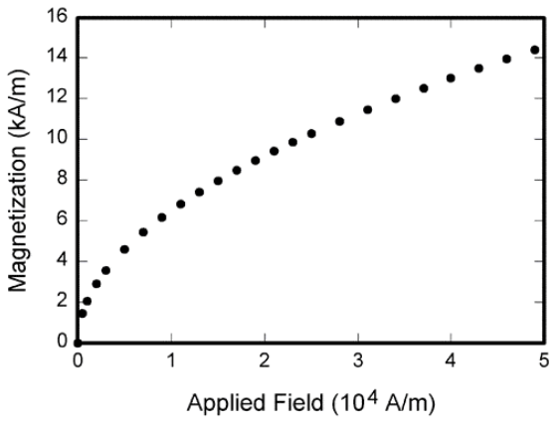
- Example of a figure caption. (figure caption)
- Table Type Styles
Table Head | Table Column Head
 | Table column subhead | Subhead | Subhead
copy | More table copy

Results

For the proceedings, a 2-4-page paper will be requested upon acceptance. The proceedings will be made available for download on the Symposium website and additionally be archived at the NRAO website. There will not be a paper print of the proceedings. In a manner, similar to previous years, a full paper version can also be submitted to the IEEE Transactions on Terahertz Science and Technology. The publications passing the standard peer-review process will then be published in an ISSTT special issue section of the IEEE Transactions on Terahertz Science and Technology.

References
- First Author, et al., “Manuscript Title”, Name of Journal, Mon. YYYY.
First Author, et al., “Manuscript Title”, Name of Journal, Mon. YYYY

¹First Affiliation, City, Postal Code, Country; ²Second Affiliation, City, Postal Code, Country; ³Third Affiliation, City, Postal Code, Country; ⁴Fourth Affiliation, City, Postal Code, Country

